Week 9 tasks 1 required downloaded 3 different types of music from freemusicarchive.org. These included a country, folk song, a minimalism, instrumental and an electronic, house track. After using Sonic Visualiser to exact a Spectrogram, Mel Frequency Cepstral Coefficients(MFCC) and Chromagrams for each and exporting individual csv files. This information was then taken to python to generate histograms from the Chroma, MFCC and Spectrogram csv files. This write up will cover the MFCC histograms, discussing the differences captured in the histograms between the tracks.

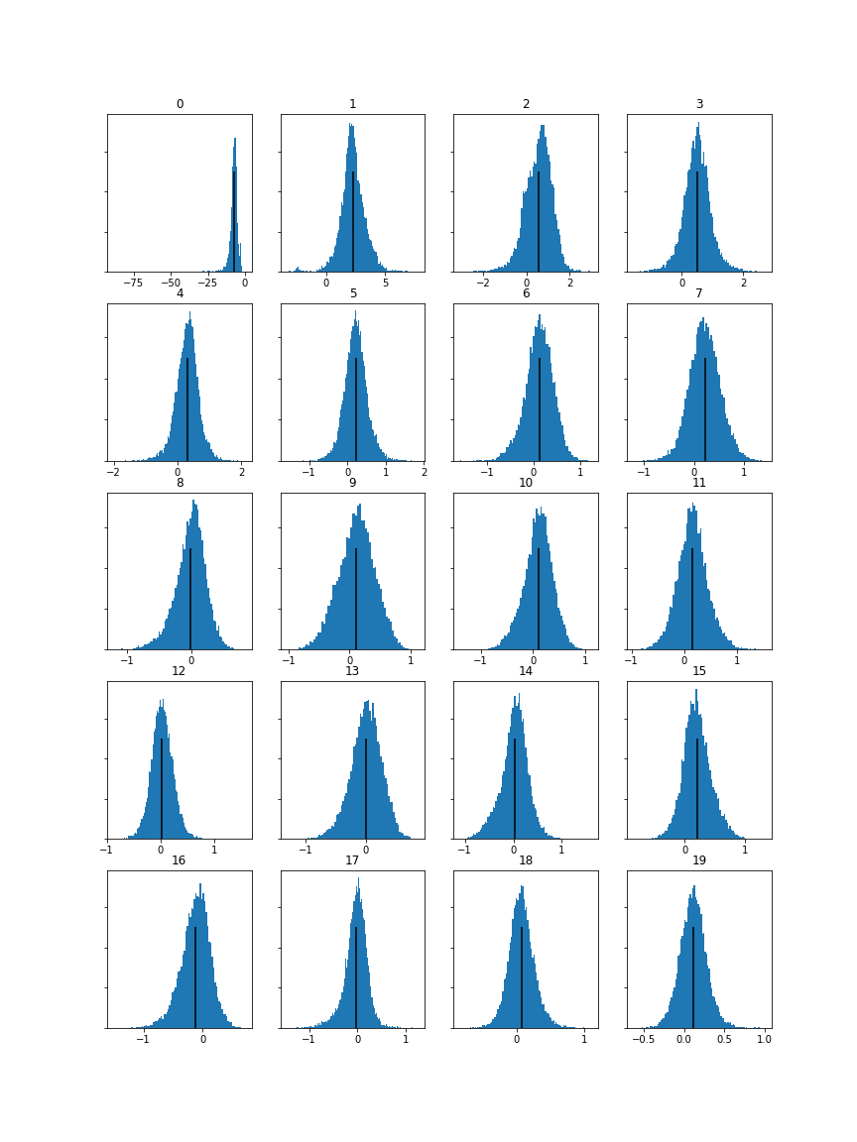

Figure 1: Orbiting the Earth, UltraCat. Genre: Electronic. MFCC Histogram. (UltraCat, 2018)

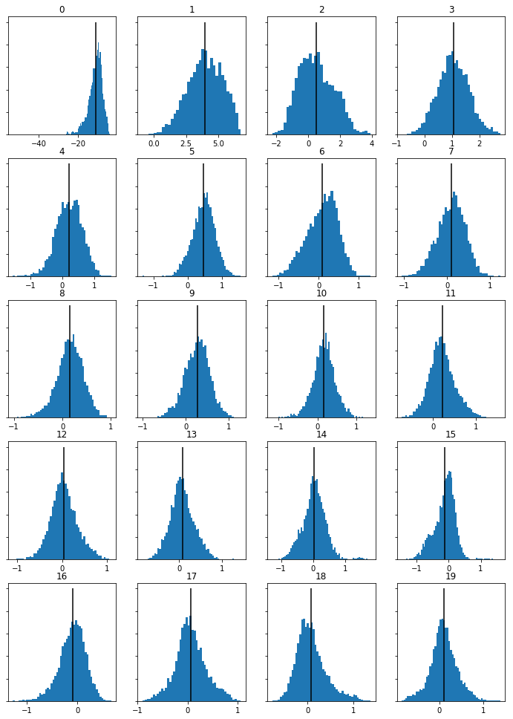

Figure 2: Rodney Skopes, Blue Dot Sessions. Genre: instrumental. MFCC Histogram (Sessions, 2018)

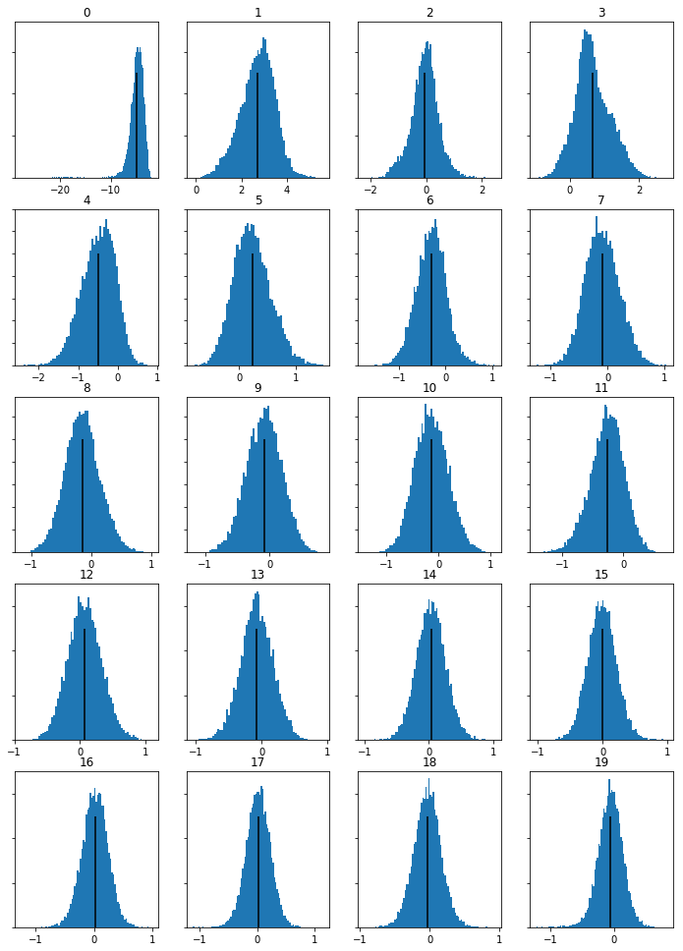

Figure 3: Caput Lupinum, Thorn and Shout. Genre: Folk. MFCC Histogram. (Shout, 2018)

These histograms represent each song, when viewing them together there is some differences and similarities. Figures 1 and 3 look similar although they are different sounding songs. Figure 2 stands out as having the most differences, this is a instrumental song.